
Company
Logotype

Cone Beam Computed Tomography- Report



Porur Dental X-rays & CBCT

Patient Name : Mr. Harish | Date of Report : 19.04.2024
Age/ Gender : 40 years/ Male | Region of Interest : CBCT Mandible
Referring doctor: 32 Dental Care | Indication : Impacted tooth
Clinical Notes: Nil
PATIENT INFORMATION

CBCT- Mandible provided
CBCT – IMAGE DETAILS

RADIOGRAPHIC INTERPRETATION

- The long axis of 38 appears slightly mesial when compared to adjacent tooth 37, with the crown of 38 in contact with the distal aspect of 37.
- The occlusal aspect of 38 lies below the occlusal aspect of 37.
- The alveolar bone in relation to 37, 38 region is present with normal trabecular pattern.
- The tooth 38 is positioned lingually and involving the lingual cortical bone.
- Distance between the apical portion of 38 and the Inferior Alveolar nerve canal: 3.04 mm.

RADIOGRAPHIC IMPRESSION

- Mesio-angularly positioned tooth: 38.

Kindly correlate with clinical findings


IMAGES FOR REFERENCE

RECONSTRUCTED PANORAMIC VIEW

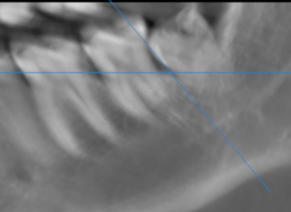

3-DIMENSIONAL VIEW

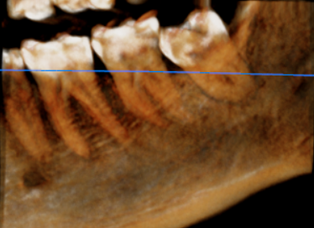

CROSS SECTIONAL VIEW

38 region- contact with the inferior alveolar nerve canal | 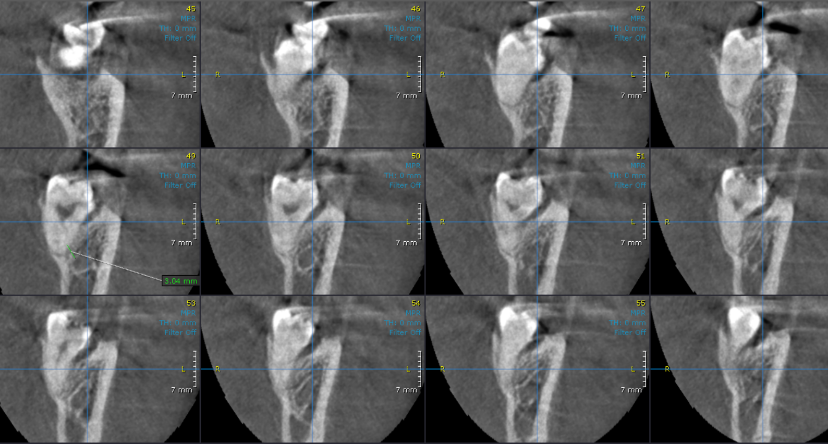

**** End of report ****

